Contents

Acknowledgements 2

I. Introduction: 3

1. I want to build an RPG game : 3

2. Game Engine: 3

3. Methodology : 3

• Pre-production: 3

• Production: 4

• Post-production: 4

• Operations: 4

4. Unity Learn: 4

5. Why Unity game engine: 6

II. Pre-production: 6

1. BrainStorming: 6

2. Scooping a similar game: Eternium 8

3. Filtering the brainstorming ideas based on available resources and scooping: 8

4. Story+plot: 10

5. Core mechanics: 10

6. Game Play: 10

7. Music/Sound: 10

8. Art style: 10

9. Project Concept 11

10. Project Timeline 13

11. Use Case diagram: 14

12. Class Diagram: 15

13. Chosen assets: 15

14. Workstation and tools: 19

15. Initial BackLog: Sprints and tasks in priority order: 19

III. Production: 20

1. Introduction :unity editor 20

2. Introduction: Scripting with visual Studio 20

3. Assets: Package Manager 22

4. User Interface: The starting scene 23

5. User Interface: The game scene 25

6. Inventory/equip system: 26

7. Touch input for smartphones: 28

8. Player Input: 28

9. Hero stats: 29

10. Unity Mechanim: 30

11. Unity Rigging: 30

12. NPC prefabs: 31

13. Terrain building tools: 32

IV. Post-production: 33

1. Unity Profiler: 33

2. Optimization and code review: 34

3. Bug fixing: 35

4. Version Control and data safety: 36

5. Polish: 37

V. Operations: 37

1. Google/iOS developer account: 37

2. Unity monetizing: 38

3. Reviews and updates: 38

4. Updates and continued maintenance: 38

VI. Conclusion: 39

# Acknowledgements

First and foremost, praises and thanks to the God, the Almighty, for His showers of blessings throughout my work to complete the project² successfully.

I would like to express my deep and sincere gratitude to my family who supported me from the start, Habib and Samia, Ahmed Yassine my little brother, Roua, Mehdi, Lotfi.

A special thank you to Randa for her huge support and tips with the paperwork and testing.

I am extremely grateful for their love, prayers, caring and sacrifices for educating and preparing me for my future.

I hold a huge respect and gratitude to all my teachers and supervisors through my 3 year studies at ISET Sousse, Prof Adnen ROUATBI,Prof Nizar ROUATBI,Prof Moez ZOUARI,Prof Wissem ELTAIEF.

Also I express my thanks especially to my supervisor Prof Adel LAARIF who guided me well and gave me precious tips and wise guidance that helped me advance and learn a lot through this project.

Finally, my thanks go to all the people who have supported me to complete the research work directly or indirectly.

Mini-RPG game

# Introduction:

## I want to build an RPG game :

RPG stands for role-playing-game , a game in which players take on the roles of imaginary characters and go for adventures. In my game dev project I will start from ‘I want to build an RPG game’ a high level statement.

## Game Engine:

Unity will be the choice of 3d real-time game engine.

* Loads of documentations and support threads.
* Loads of free assets for commercial use.
* Free* (with a yearly revenue cap).

## Methodology :

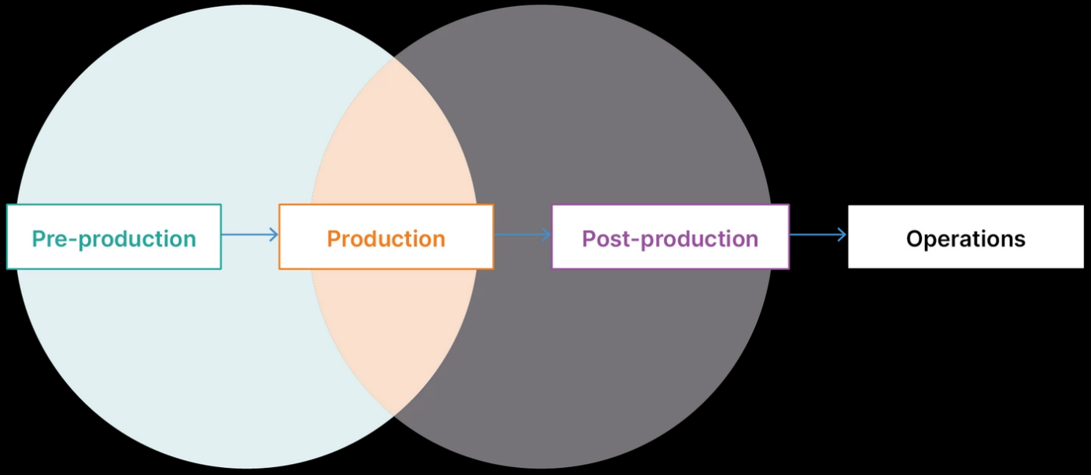

It is consisted mainly of 4 phases of production:

### Pre-production:

planning, prototyping and initial designs. Scrum Style: backlog +sprints planning.

### Production:

creation of the product and assets ,user interfaces ,gameplay ,it is the important and largest part. It will be based on Kanban agile method.

### Post-production:

quality assurance (QA), editing, testing, bug fixing, and final polishing.

### Operations:

sales, monetization, updates (going through pre-production again), and continued maintenance.

## Unity Learn:

Unity Essential Pathway: 2 weeks duration: 1🡪15 Mars 2021

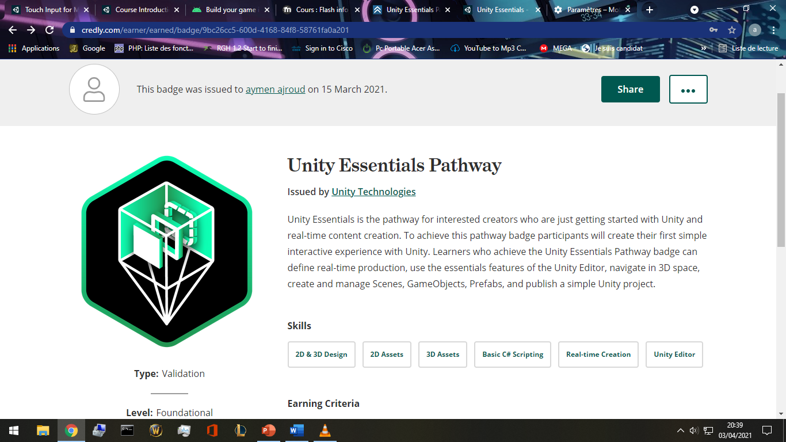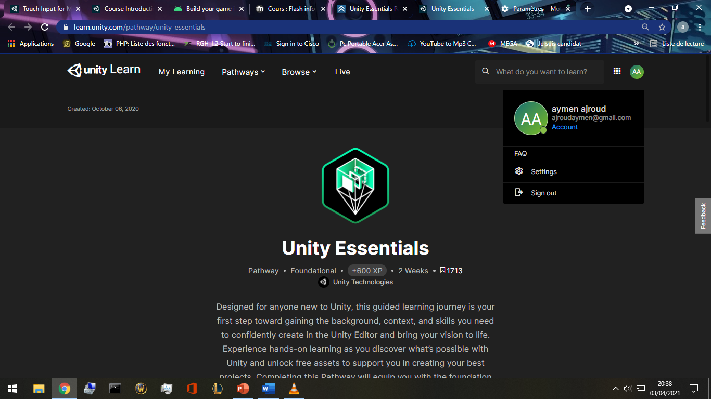<https://learn.unity.com/pathway/unity-essentials>

<https://www.credly.com/badges/9bc26cc5-600d-4168-84f8-58761fa0a201/public_url>

Unity Junior Programmer: 15🡪29 Mars 2021:

<https://learn.unity.com/pathway/junior-programmer>

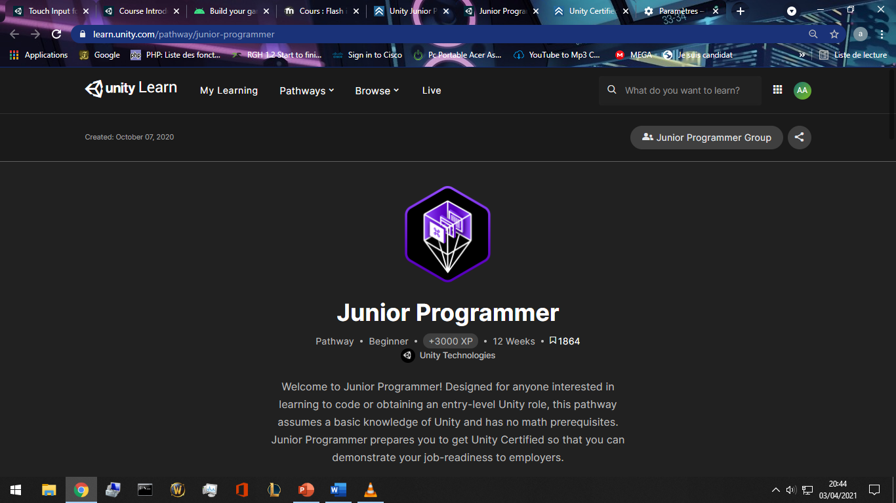

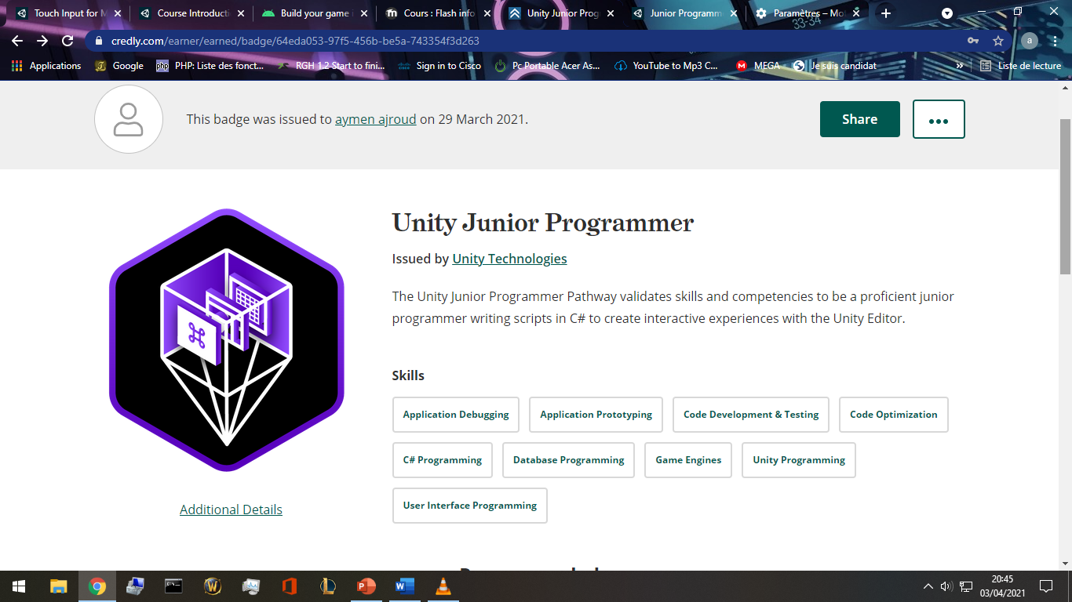<https://www.credly.com/badges/64eda053-97f5-456b-be5a-743354f3d263/public_url>

## Why Unity game engine:

* Full of license-free assets : <https://assetstore.unity.com/account/assets>.
* Rich documentation :a huge online manual, <https://docs.unity3d.com/Manual/index.html>
* a huge communities with tons of threads and debugging: forum.unity.com ,
* blogs.unity3d.com, reddit.com.
* C# base coding language.
* Real-Time testing :I can run the game whenever I want using the editor built in
* real-time emulator along with a “Profiler” that calculate frames, resources consumption, all technical info , all for the cause of optimization.
* An impressive link with microsoft visual studio for advanced scripting and easy documentation.

# Pre-production:

## Brainstorming:

I have spent 3 days writing down any idea I think of, at any time, and anywhere.

* Level system with experience points.
* With/without level cap.
* Stamina (hp), scalable with items/level
* Multiplayer
* Offline solo
* OpenWorld
* Stages, each stage have small map, stage=scene.
* Classes like warrior rogue mage priest
* Resources like mana rage energy
* Casting skills/spells
* Talent points tree
* Achievement’s system
* Google play implementation
* Guest login/ linking account.
* Skills and spells upgradable
* Money system (gold, coins, gems,)
* Storyboard (implementing a manga/anime…)
* Characters to start with(female/male) race human/other imaginaries.
* Quest/reward system.
* Npc (Non Player Characters) quests, trading (sell buy).
* Inventory system
* Character equip system
* Character stats interface
* Enemies to kill (drop items/money/experience/quests requirements).
* Moving touch pad, spells/skills button list
* Free look button
* Swipe to fast cast spells/skills
* duel with other players with pvp reward system
* daily + weekly quests
* 2 or more factions to join.
* Guild system
* Messaging system/mailbox
* Compare achievements with others in a scoreboard.
* Items with levels and rarity
* Fixed view
* Customized view
* Options interface (menu quit volume graphic quality)
* Mini map
* Customizing the controls size/visibility/position
* Pets that follow you and help attack
* Compagnions that can equip items and use skills.
* Crafting tab: salvage items and create higher lvl ones.
* Tap enemies to attack
* Payment ui.
* Googleplay plugin
* Global/guild/party chat system
* Party with friends and play together

## Scooping a similar game: Eternium

* I really like the gameplay but it feels like I hit the Wall where the Grind begins and nothing else other than running endless Trials is progress. Crafting Items isnt worth it cause i need Set/Named items. And there is nothing else to farm other than CL, everything else will drop or wont. *Reddit.com/*
* **Eternium** is an amazingly fun and beautifully crafted Action RPG, reminiscent of the **great** classics. **Eternium** stands out from other mobile Action RPGs by its effortless “tap to move” and innovative “swipe to cast” controls, and its player-friendly “no paywalls, never pay to win” philosophy. *Amazon.in/*

*\*\*google playstore reviews\*\**

* Stats decrease when u lvl up , why not increased? lacking joystick support.
* Upgrade skills by gems instead of skill points. Sorta of pay to win.
* No stamina/energy to limit gameplay.
* Old graphics
* The concept to draw lines to use items/cast spell or skill is innovative.
* Low experience gain rate.
* Grinding for items.
* Free play, don’t have to daily check in.
* No blood or gore so all ages are welcome.
* Small font and bad resolution compatibility on some phones.
* No too easy where it becomes boring.
* Returning to a level and grinding again and again for experience with same story dialogues showing is boring.
* Bad item drop rate
* Progression for new characters are slow.
* Problem with the crafting tab user interface UI.
* Pvp(player-vs-player) is unbalanced, matching players gear is bad.
* Interactive support in google playstore review section.

## Filtering the brainstorming ideas based on available resources and scooping:

* Level system with experience points.
* With~~/without~~ level cap.
* Stamina (hp), scalable with items/level
* ~~Multiplayer~~
* Offline solo
* OpenWorld
* Stages , each stage have small map, stage=scene.
* ~~Classes like warrior rogue mage priest~~
* Resources like mana rage energy
* Casting skills/spells
* Talent points tree
* Achievements system
* Google play implementation
* Guest login/ linking account
* Skills and spells upgradable and unlockable by lvling up
* Money system (gold , coins, gems,)
* Storyboard (implementing a manga/anime…)
* Characters to start with(female/male) race humain~~/other imaginairies.~~
* Quest/reward system.
* Npc (NonPlayerCharacters) quests, trading (sell buy).
* Inventory system
* Character equip system
* Character stats interface
* NPC Enemies to kill (drop items/money/experience/quests requirements).
* Moving touch pad, spells/skills button list
* Free look button
* Swipe to fast cast spells/skills
* ~~duel with other players with pvp reward system~~
* daily + weekly quests
* ~~2 or more factions to join~~
* ~~Guild system~~
* Messaging system/mail box
* Compare achievements with others in a scoreboard
* Items with levels and rarity
* Fixed view
* ~~Customized view~~
* Options interface (menu quit volume graphic quality)
* Mini map
* Customizing the controls size/visibility/position
* ~~Pets that follow you and help attack~~
* ~~Compagnions that can equip items and use skills.~~
* ~~Crafting tab: salvage items and create higher lvl ones.~~
* ~~Tap enemies to attack~~
* Payment ui.
* Google play plugin
* Global/guild/party chat system
* ~~Party with friends and play together~~

## Story+plot:

A hero came to save the village from skeletons, take quests, gather, kill , find, and return for exp and glory.

## Core mechanics:

* player can move freely.
* Talk to npcs in the village for questing.
* Attack goblins.
* Find stolen items.
* Gather herbs.

## Game Play:

1st you choose between a male/female character, then you spawn beside a village. You can move freely in the open world. Kill threatening skeletons ,find rare items, collect herbs for quests to earn experience and level up.

## Music/Sound:

A calm music running in background.

## Art style:

Medieval style of sword and magic.

## Project Concept

|  |  |  |  |  |  |  |
| --- | --- | --- | --- | --- | --- | --- |
| 1  **Player Control** |  | You control a   |  | | --- | | *A male/female character* | | in this   |  |  | | --- | --- | | *Top down view* | game | |
|  | where   |  | | --- | | *The touch pad+buttons* | | makes the player   |  | | --- | | *move run attack* | |

|  |  |  |  |  |  |  |
| --- | --- | --- | --- | --- | --- | --- |
| 2  **Basic**  **Gameplay** |  | During the game,   |  |  | | --- | --- | | *Enemies/friendly npcs* | appear | | from   |  | | --- | | *Moving around the open world stage* | |
|  | and the goal of the game is to   |  | | --- | | *Complete missions, earn money, upgrade skills and leveling up* | | |

|  |  |  |  |  |  |
| --- | --- | --- | --- | --- | --- |
| 3  **Sound**  **& Effects** |  | There will be sound effects   |  | | --- | | *when moving, attacking, dying, enemy dying, friendly npcs talk* | | and particle effects   |  | | --- | | *when Dying, moving, finishing quests, leveling up* | |
|  | [*optional*] There will also be   |  | | --- | | *All characters have basic animation effect.* | | |

|  |  |  |  |  |  |
| --- | --- | --- | --- | --- | --- |
| 4  **Gameplay**  **Mechanics** |  | As the game progresses,   |  | | --- | | *Enemy level increases, quests rewards increases, experiencee needed to lvl up increases, talent points* | | making it   |  | | --- | | *Scallable* | |
|  | [*optional*] There will also be   |  | | --- | | *when you die, you need to watch an ad video or wait ? minutes to respawn* | | |

|  |  |  |  |  |  |  |  |
| --- | --- | --- | --- | --- | --- | --- | --- |
| 5  **User**  **Interface** |  | The   |  | | --- | | *Money* | | will   |  | | --- | | *Increase* | | whenever   |  | | --- | | *loot enemies/sell items* | |
|  | At the start of the game, the title   |  |  | | --- | --- | | *hero* | will appear | | | and the game will end when   |  | | --- | | *Doesn't end,level cap, dangeons, bosses, loot, items.* | |

## Project Timeline

|  |  |  |
| --- | --- | --- |
| Milestone | Description | Due |
| **#1** | |  | | --- | | * *Menu/start/quit ui + 1st stage+controls+characters+npc+ennemies+deploy to googleplay store* | | |  | | --- | | *29/04* | |
| **#2** | |  | | --- | | * *log in functionality+google play integration+back end server+databases* | | |  | | --- | | *29/05* | |
| **#3** | |  | | --- | | * *optimization+adding more features +ads+billing system* | | |  | | --- | | *15/06* | |
| **#4** | |  | | --- | | * *more code optimization+release of more stages.+facebook page+advertizing* | | |  | | --- | | *30/06* | |

## Class Diagram:

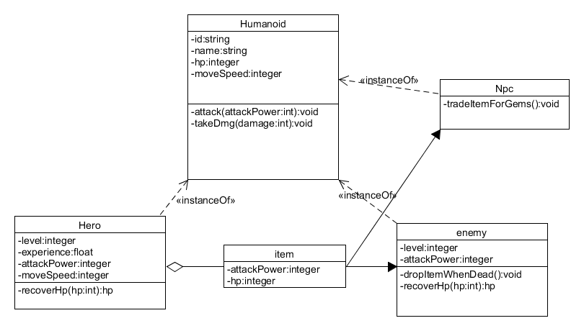

## Chosen assets:

|  |  |  |
| --- | --- | --- |
|  | <https://assetstore.unity.com/packages/3d/characters/humanoids/girl-with-clothes-worker-set-162925> | A female villager with idle animation only |
| screenshot | <https://assetstore.unity.com/packages/3d/characters/humanoids/fantasy/oriental-fantasy-character-berserker-grade-0-171147> | Female hero with animations |
| screenshot | <https://assetstore.unity.com/packages/3d/characters/humanoids/humans/fantasy-chess-rpg-character-arthur-160647> | Male Hero with animations |
| screenshot | <https://assetstore.unity.com/packages/2d/gui/fantasy-wooden-gui-free-103811> | Ui materials |
| screenshot | <https://assetstore.unity.com/packages/3d/environments/nature-starter-kit-2-52977> | Nature kit 3d |
|  | <https://assetstore.unity.com/packages/3d/characters/humanoids/fantasy/rpg-skeleton-35463> | Skeleton 3d with animations |
|  | <https://assetstore.unity.com/packages/2d/gui/icons/basic-rpg-icons-181301> | Basic rpg game icons |
|  | <https://assetstore.unity.com/packages/3d/environments/fantasy/fantasy-forest-environment-free-demo-35361> | Trees/bush 3d prefabs |
| screenshot | <https://assetstore.unity.com/packages/tools/version-control/github-for-unity-118069> | GitHub unity plugin |
|  | <https://assetstore.unity.com/packages/3d/animations/villager-animations-free-157920> | Villager animation pack :mining , fishing …. Works on humanoid unity rig. |
|  | <https://assetstore.unity.com/packages/vfx/particles/fire-explosions/fire-spell-effects-36825> | Fire & Spell Effects |
|  | <https://assetstore.unity.com/packages/3d/characters/humanoids/character-elf-114445> | Character elf |
|  | <https://assetstore.unity.com/packages/3d/characters/humanoids/humans/basic-bandit-89978> | Basic bandit character |
|  | <https://assetstore.unity.com/packages/3d/animations/rpg-character-mecanim-animation-pack-free-65284> | RPG Character Mecanim Animations |
| screenshot | <https://assetstore.unity.com/packages/2d/textures-materials/nature/terrain-tools-sample-asset-pack-145808> | Terrain Tools Sample Asset Pack |
|  | <https://assetstore.unity.com/packages/3d/environments/landscapes/rpg-poly-pack-lite-148410> | RPG Poly Pack - Lite |
|  | <https://assetstore.unity.com/packages/audio/sound-fx/footstep-snow-and-grass-90678> | Footstep(Snow and Grass) |
|  | <https://soundimage.org/fantasywonder/> | Royalty free music and SFX |

## Workstation and tools:

* Motherboard: H310M PRO-VD PLUS
* CPU: intel i5 9400F 2.9 GHz
* GPU: Nvidia GeForce GTX 1650
* Screen: 32” Vega Led
* Umlet: a powerful diagram designer and freeware.
* SketchBook: a freeware and easy to use image editor.
* Microsoft windows Paint.(who doesn’t know Paint)
* Unity editor 2020.3.5f1 LTS
* Blender
* Microsoft office suite validated with the institute office 365 email aymen.ajroud@sousse.r-iset.tn .
* GitHub student pack: GitHub pro, activated by applying with institute email. With GitHub pro student pack I have access to more then hundred hosting/storage/databases and many more services on 3rd party providers like Microsoft azure student pack, canva.com , digital ocean,… https://education.github.com/pack
* Firebase.google.com , free basic plans for start ups, cloud storage, Realtime database NoSQL , statistics , web hosting, user authentication .Easy and documented implementation with unity projects.
* Hundreds of free assets in unity assets store for commercial use.

## Initial BackLog: Sprints and tasks in priority order:

* UI: user interface, login/link interface (dead buttons), support, faq,
* Building initial map
* Graphic settings interface
* Inventory system
* Equip system
* Controls: player input, touch pad.
* Hero stats
* Villager npcs,quest system,and enemy skeletons.
* Environment details,map details.

# Production:

## Introduction :unity editor

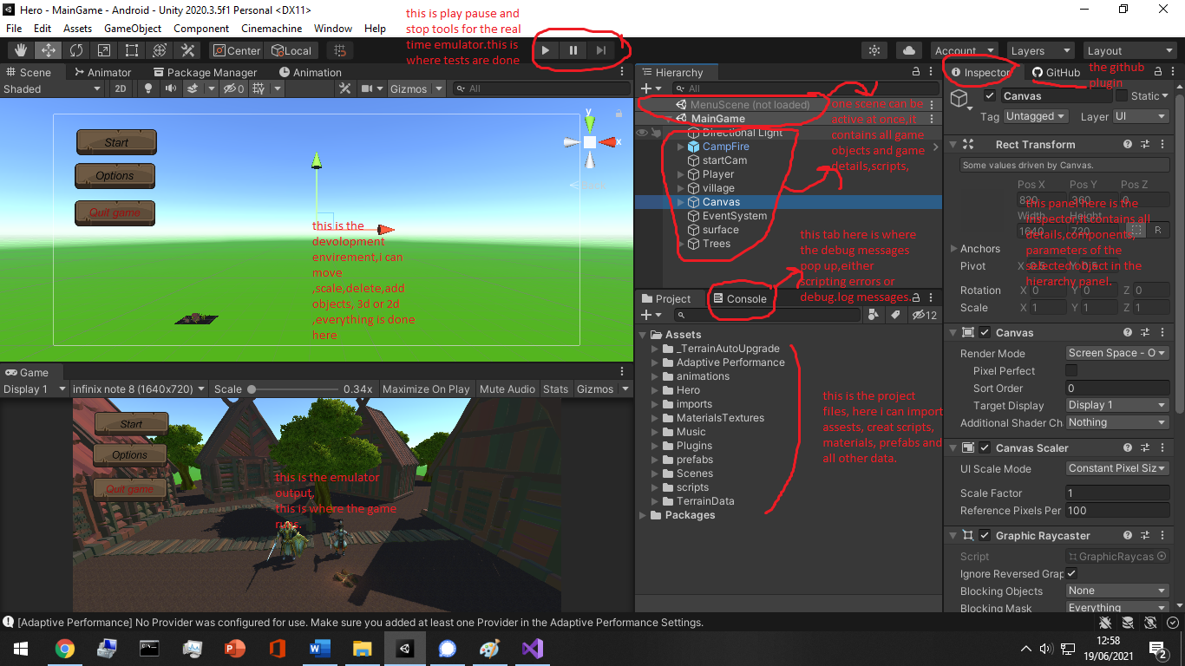

## Introduction: Scripting with visual Studio

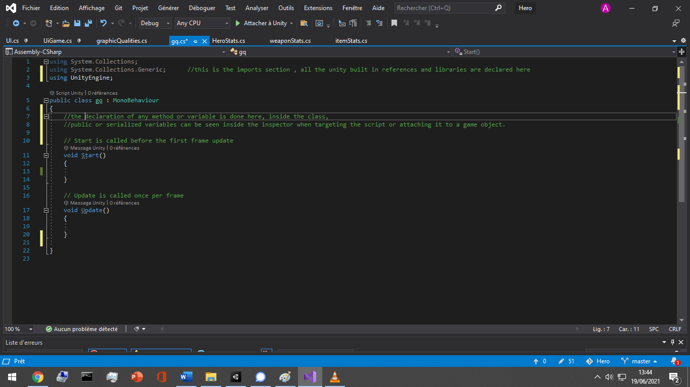

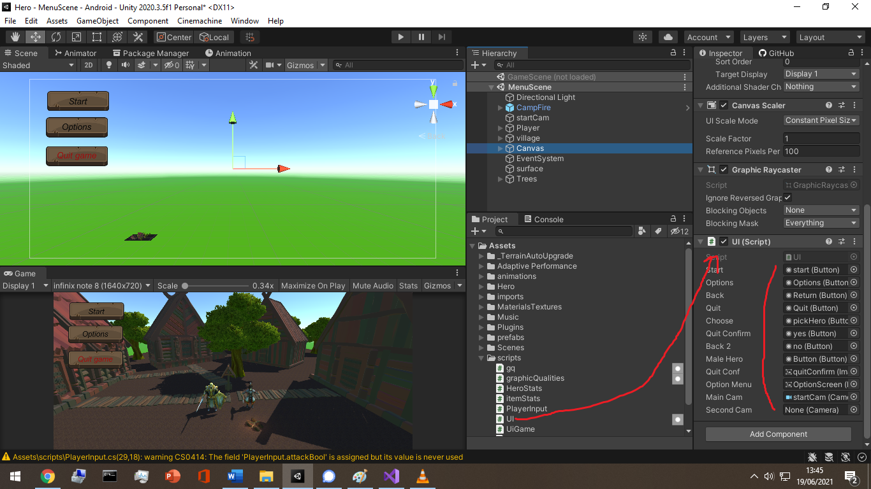

When declaring an object as a public variable inside a script, I need to drag and drop it in the inspector otherwise It gives a null pointer reference if I try to access an empty object.

Example of treatment on a text object : change its value, turn it to inactive state, change its parameters , all through scripting.

## Assets: Package Manager

The built in unity 2020 packageManager can directly download and import assets from my owned assets related to my unity account. 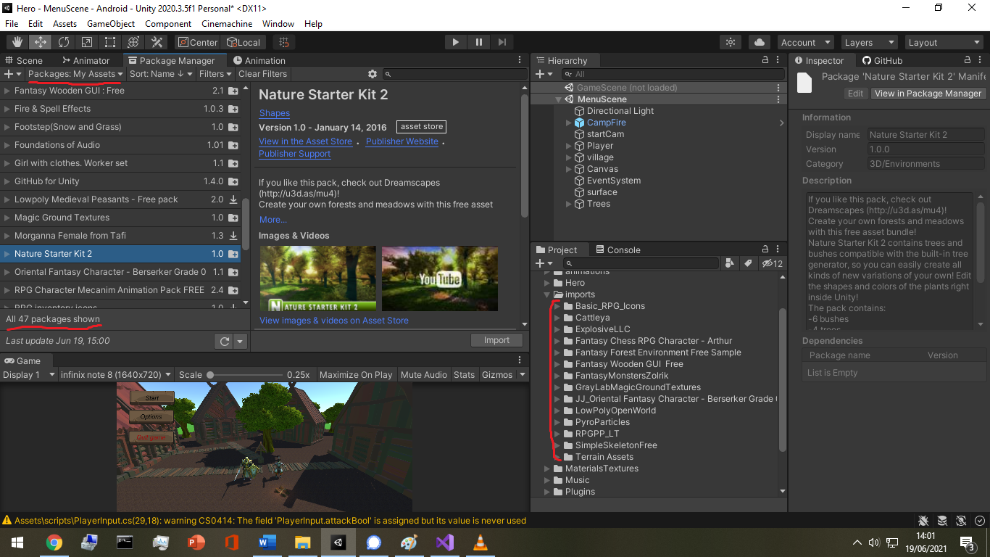

All assets are free to use commercially.

Exterior websites for other assets: <https://www.cgtrader.com/> <https://soundimage.org/>

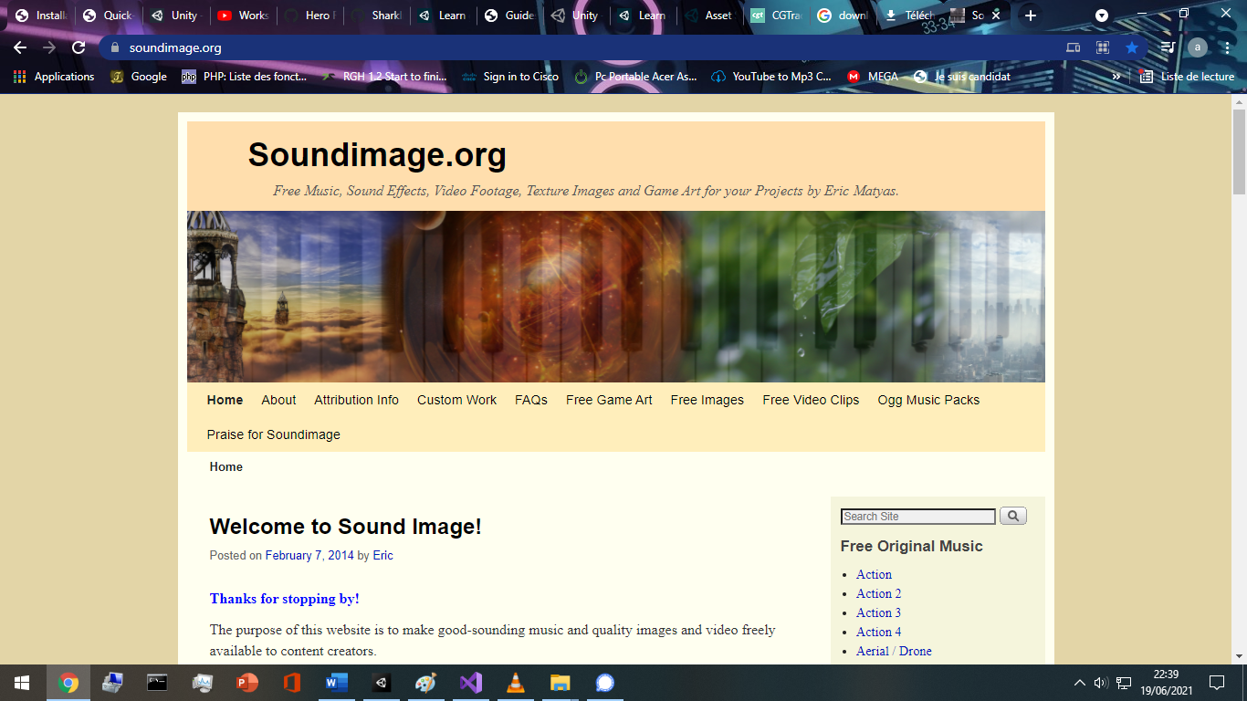

## User Interface: The starting scene

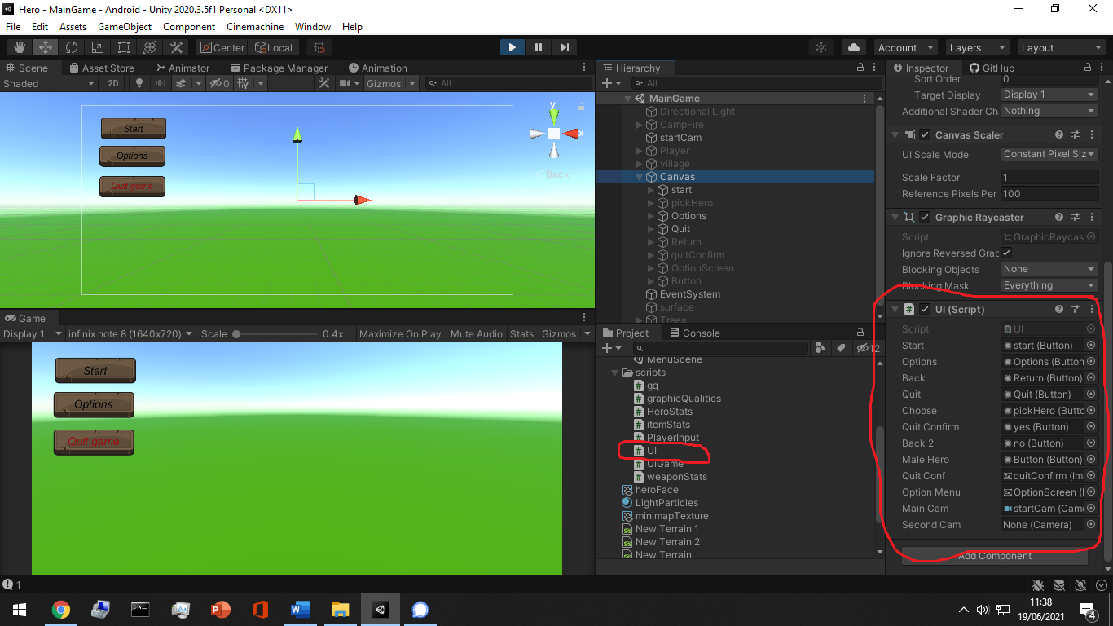all the **canvas** children are attached and declared in **its** script as variables to do what ever is needed along the scripting.

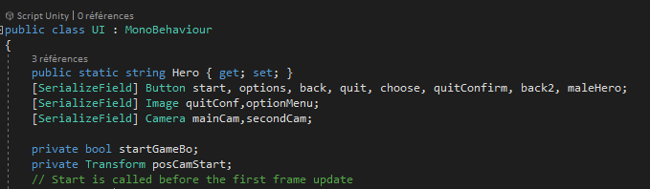

In the case of a button/image or any object that should start an event when triggered can extend the onclick events, or I can simply use the built in onclick trigger in the unity inspector.

That’s almost how ui objects event system works.All the treatments and the events are inside the called method in the onClick Panel.

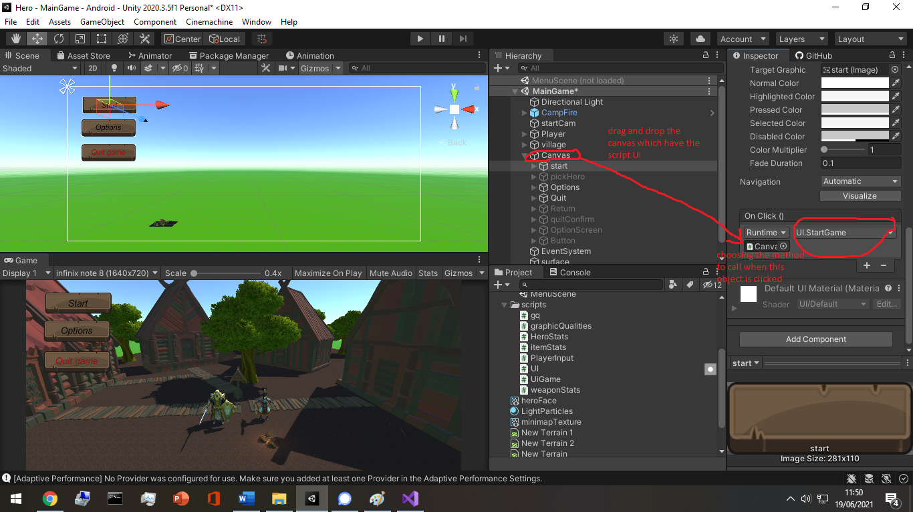

As for saving the settings stats and players preferred settings, there exists a static class in unity named PlayerPrefs that can save data as a key-value pairs. This is almost the same concept for every other settings.

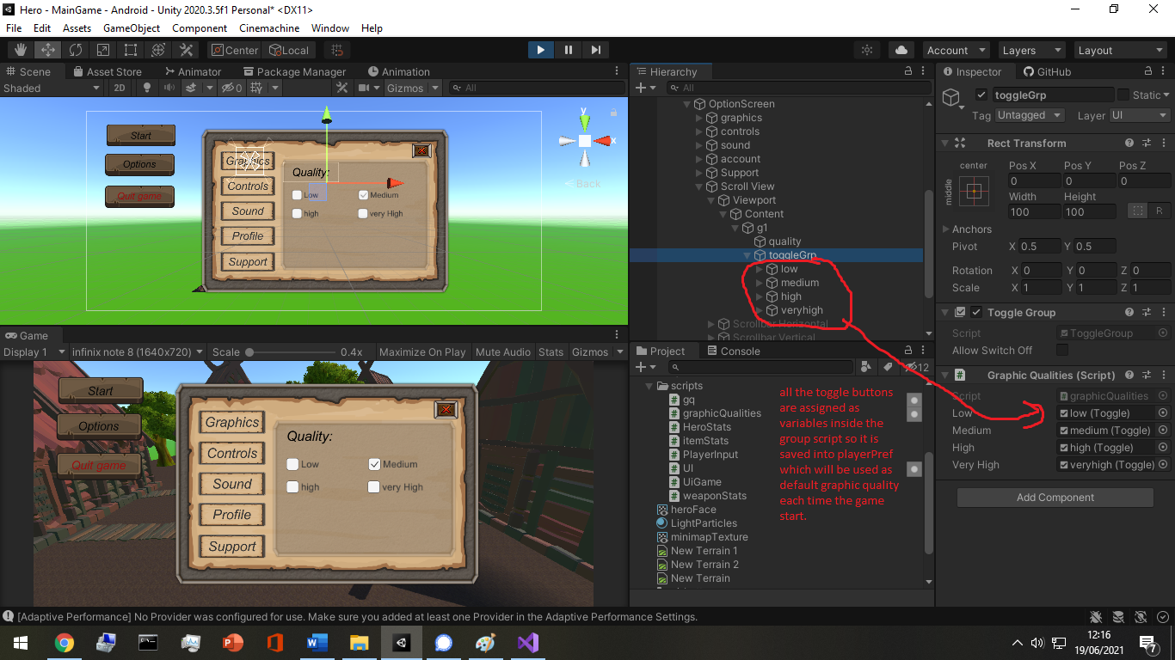

## User Interface: The game scene

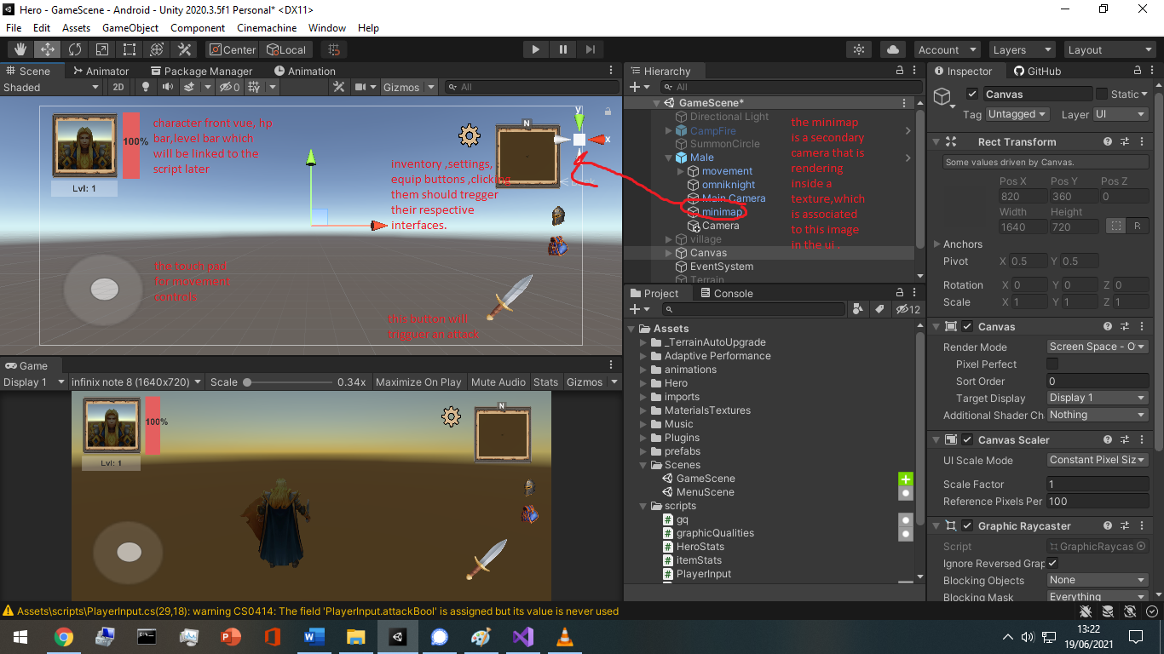

When building ui interface, I found that the order in the hierarchy matters a lot since ui objects in the upper order are rendered on top of the lower level ones.

The input key “escape” is the same as the android return button , so I need to implement this input in order to interact with the interface as well.

The input system should always be in the update() method in a script.

Update() is called every frame, and every device screen have a frame rate and is calculated as fps (frame per second).A frame is simply an image.

## Inventory/equip system:

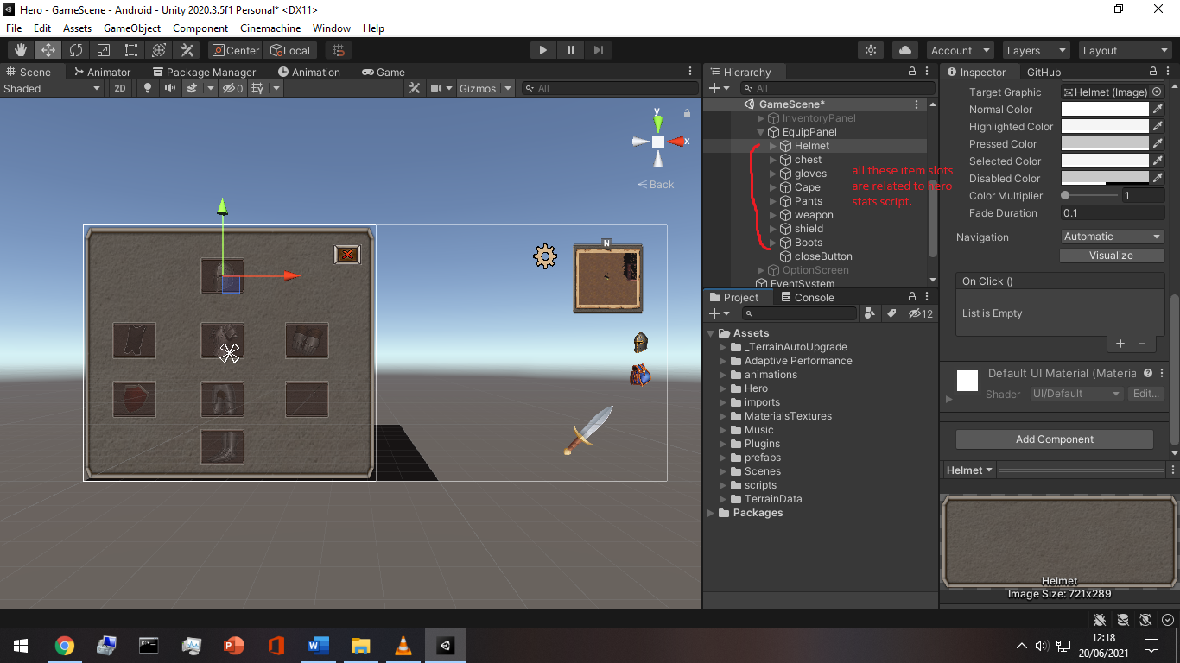

An item is built with a ui button interface, it has an icon and on click, it shows its stats in a panel. This is what we call in unity , a prefab. Here an example of a sword level 1 with 100 attack power and ready for adding more stats and other info and constrains.

The text for UI elements and text meshes can incorporate multiple font styles and sizes. Rich text is supported both for the UI System and the legacy GUI system. The Text, GUIStyle, GUIText and TextMesh classes have a Rich Text setting which instructs Unity to look for markup tags within the text.

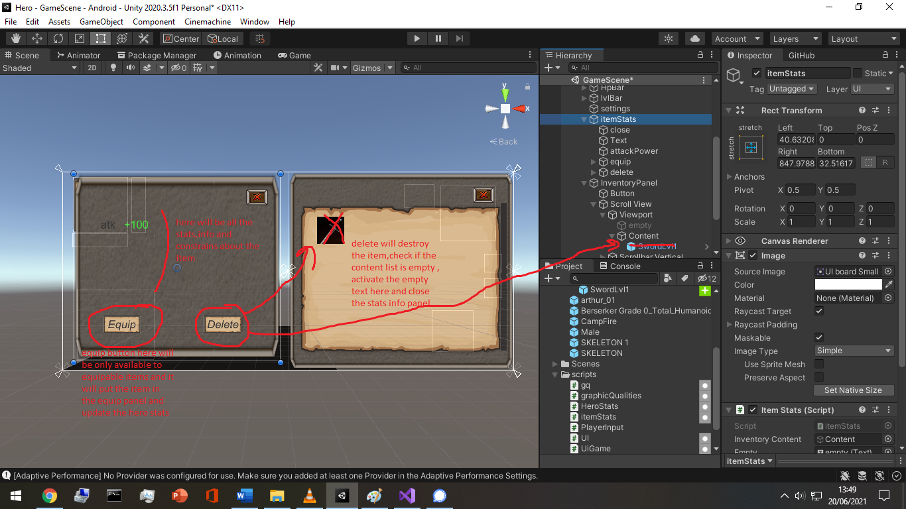

Here is an example pf script.

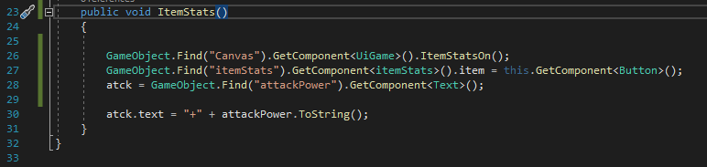

This method is called when the item is clicked on and this is where the item stats will be transferred to the item stats panel on the left side.

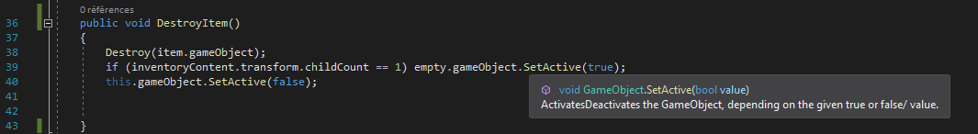

This is called when the destroy item is clicked.

## Touch input for smartphones:

Smartphone devices can track up to five fingers touching the screen simultaneously. You can retrieve the status of each finger touching the screen during the last frame by accessing the *Input.Touches* property array.

The most important property parts are the position, id, and the phase.

The phase have 5 states: Began, Moved, Stationary, ended and canceled.

## Player Input:

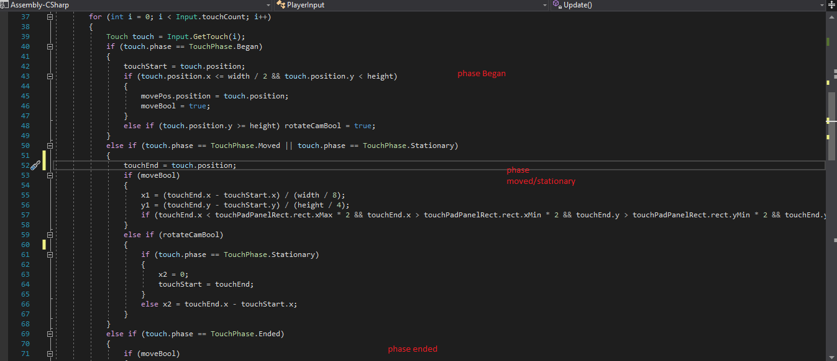

When dealing with player moving object, animations and FX either visual or sound. 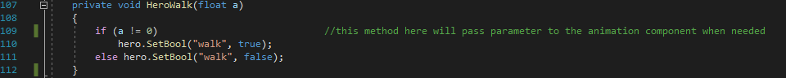

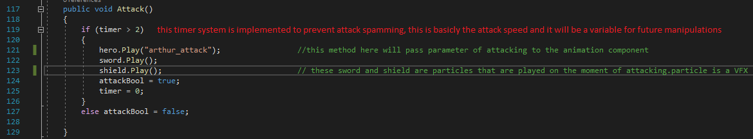

## Hero stats:

The hero object will have heroStats.cs script attached to it and from there all ui texts will be referenced here.

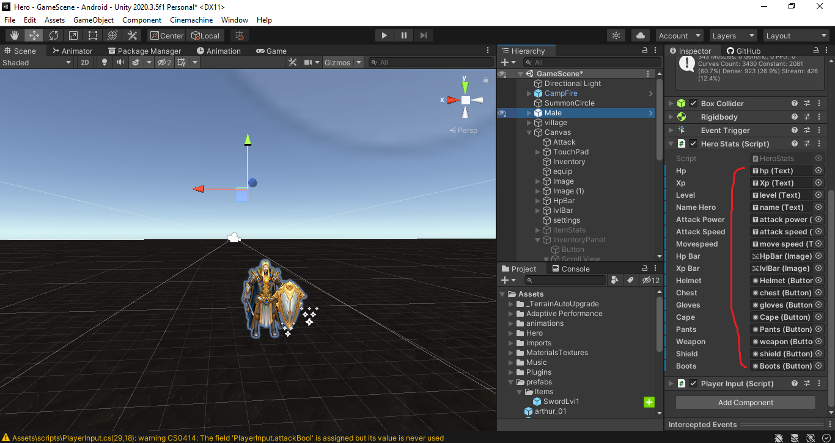

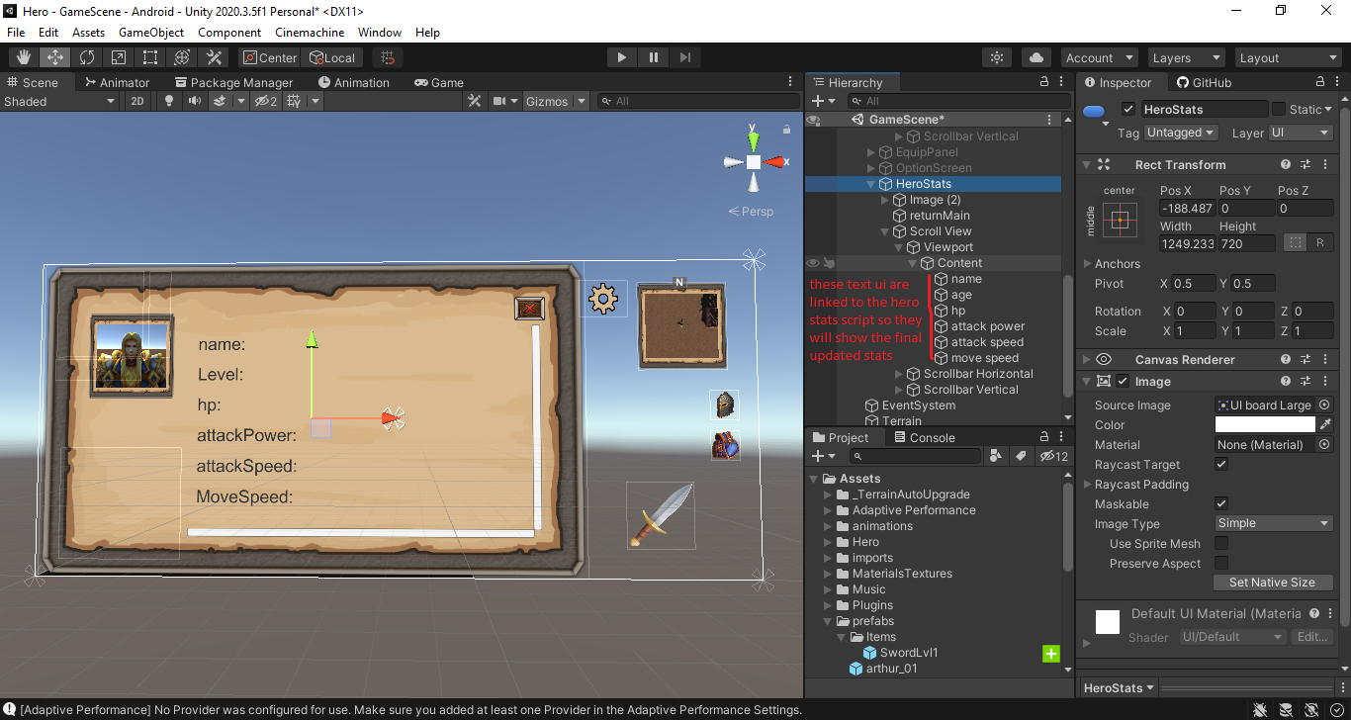

## Unity Mechanim:

Unity has a rich and sophisticated animation system called Mecanim. Mecanim provides:

* Easy workflow and setup of animations on humanoid characters.
* Animation retargeting - the ability to apply animations from one character model onto another.
* Simplified workflow for aligning animation clips.
* Convenient preview of animation clips, transitions and interactions between them. This allows animators to work more independently of programmers, prototype and preview their animations before gameplay code is hooked in.
* Management of complex interactions between animations with a visual programming tool.
* Animating different body parts with different logic.

## Unity Rigging:

The Animation **Rigging** package for **Unity** enables users to set up procedural motion on animated skeletons at runtime. This makes it possible to do powerful things during gameplay such as world interactions, skeletal deformation **rigging**, and physics-based secondary motion. Most of the free assets are “rigged” and ready for mechanim.

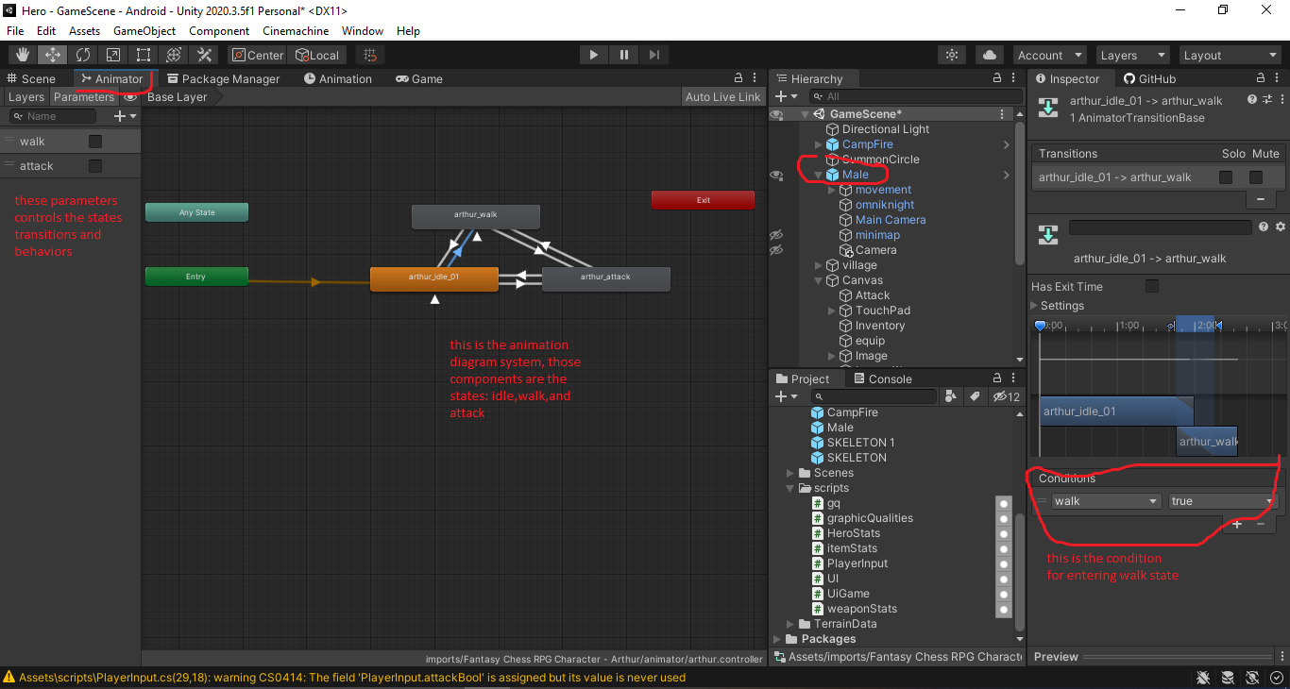

This is unity Mecanim tool for controlling animation flow.

And this one below for rigged humanoid characters.

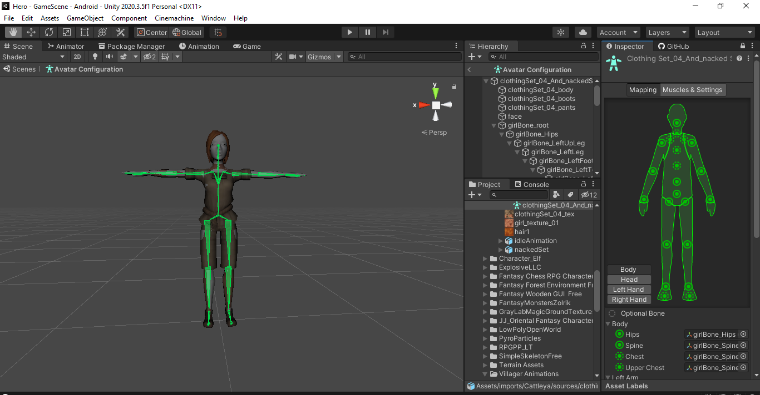

## NPC prefabs:

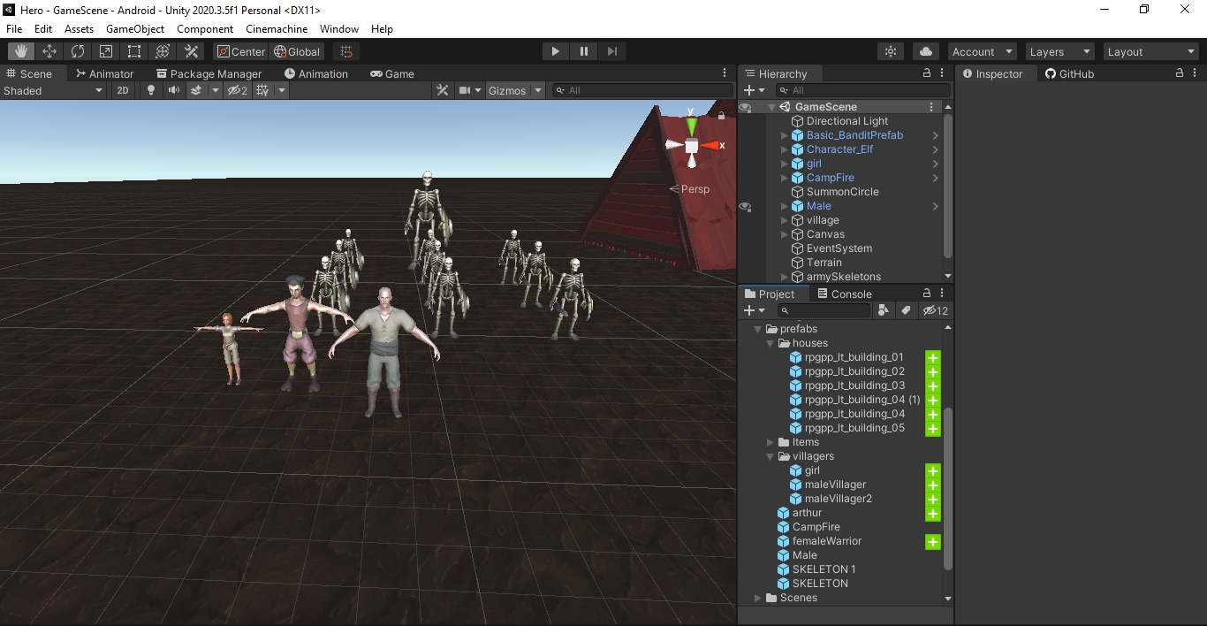

Unity’s **Prefab** system allows you to create, configure, and store a GameObject complete with all its components, property values, and child **GameObjects as** a reusable Asset. The Prefab Asset acts as a template from which you can create new Prefab instances in the **Scene.**

## Terrain building tools:

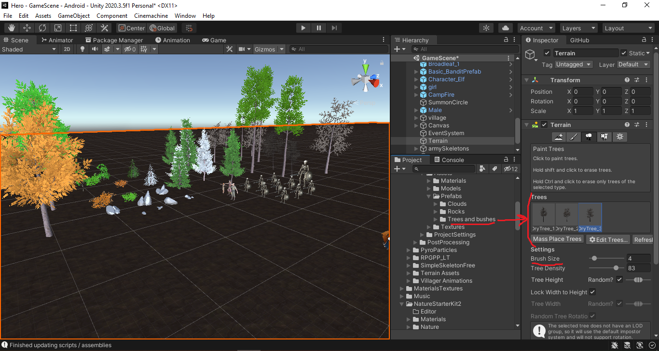

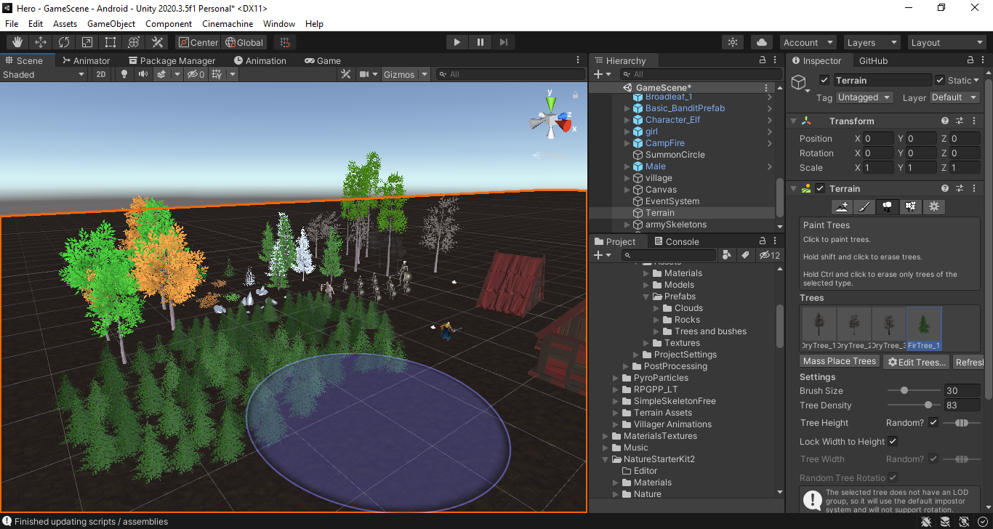

The terrain tool panel makes building terrain vegetation very quick with the use of a brush that have a dynamic size from 1 tree to hundreds.

There is also the terrain painting:

* Raise or lower terrain to build rivers, mountains, hills.
* Paint holes(remove part from terrain).
* Paint textures (dirt, snow…).

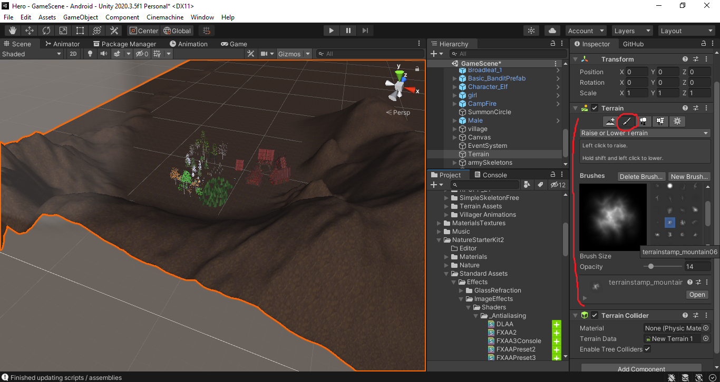

# Post-production:

## Unity Profiler:

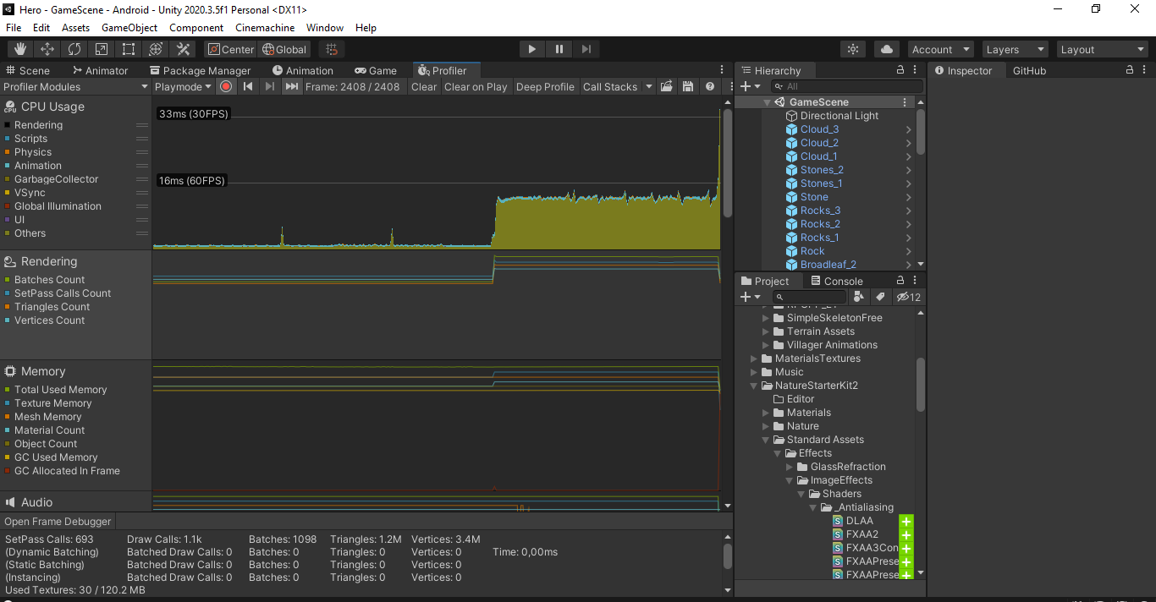

The Unity Profiler is a tool you can use to get performance information about your application. You can connect it to devices on your network or devices connected to your machine to test how your application runs on your intended release platform.

You can also run it in the Editor to get an overview of resource allocation while you are developing your application.

The Profiler gathers and displays data on the performance of your application in areas such as the CPU, memory, renderer, and audio. It’s a useful tool to identify areas for performance improvement in your application and iterate on those areas. You can pinpoint things like how your code, assets, scene settings, camera rendering, and build settings affect your application’s performance. It displays the results in a series of charts, so you can visualize where spikes in your application’s performance happen.

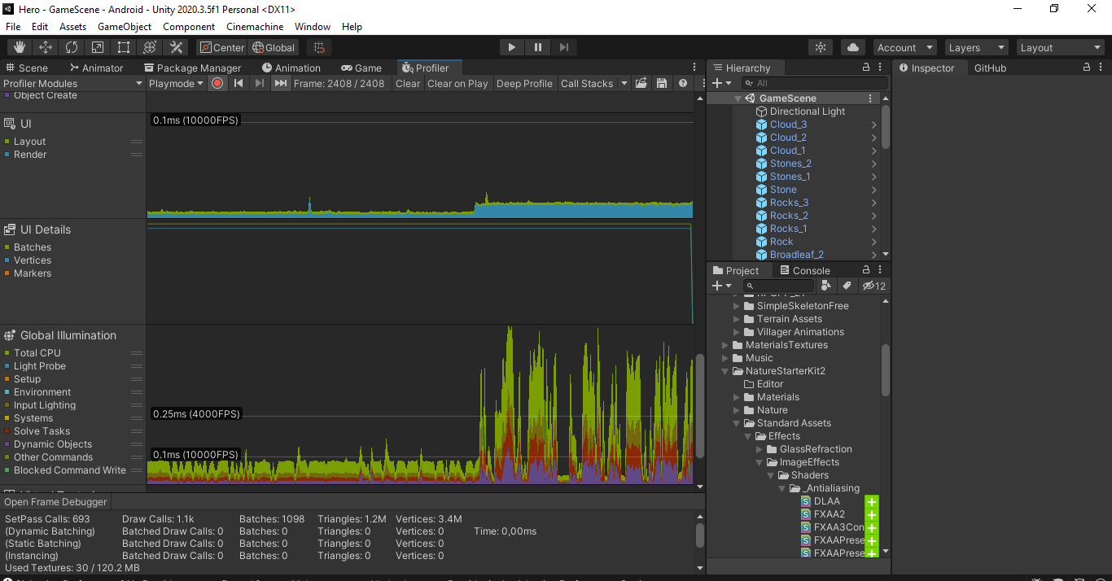

## Optimization and code review:

When developing, optimization should come naturally while coding, here are some tips for RPG kind of games:

* Reduce the music/audios format to keep it light.
* Compress/reuse textures.
* Remove unused assets items.
* Smaller games are faster to download and require less data on initial install, and eventually higher install conversions. Texture compression formats.
* Reduce events number in a scene.
* Reduce/re-use effect plugins (lightning, sounds, particles [or anything that includes "advanced" physics], etc.).
* Support 64-bits architectures.
* Use unity profiler and analyze game performance/requirements.
* Clean code.
* Always add comments.
* Keep it simple.
* Static batching (static objects reduce hugely resource consumption, so whenever an object doesn’t move, make it static).
* Dynamic batching (combine meshes ).
* Culling to limit what’s rendering (Imagine standing in front of a door and still rendering all objects behind that door. This is where Occlusion Culling comes in).
* Reducing physics computing (It's important to note that having too many Rigidbody objects within your game will affect performance negatively.)
* Object Pooling (Pooling commonly used objects allows you to reuse them repeatedly without destroying them).
* Coroutines/update (update will happen every frame, so coroutines sometimes reduce a lot of work).
* Cashing Components (for example Don't use GetComponent multiple times in a method when you can cache it once and use that variable throughout the script.).
* Better to manually assign objects in the script component then using the gameobject.find().
* if you are not using something, turn it off.
* in general, you should use the minimum amount of light necessary to achieve your desired style.
* Enable Instancing option within unity.

## Bug fixing:

The game will have bugs. Every game has bugs and this one will not be an exception. The question is, how do you deal with bugs. If you know your bugs are getting out of hand it might be a good idea to stop working on new features and focus on stabilizing the build until things are back on track.

If you identify a system that is constantly causing problems, it might be worth the time to rebuild it instead of repeatedly fixing the issues it causes.

## Version Control and data safety:

Even today, with the availability of free version control systems (VCS), there are still teams out there working with shared folders or drop boxes to collaborate. Developing without version control is a bit like driving without a seat belt. Wearing a seat belt might not always be comfortable and will restrict you a bit, but once you crash full speed into that tree, it will save your life.

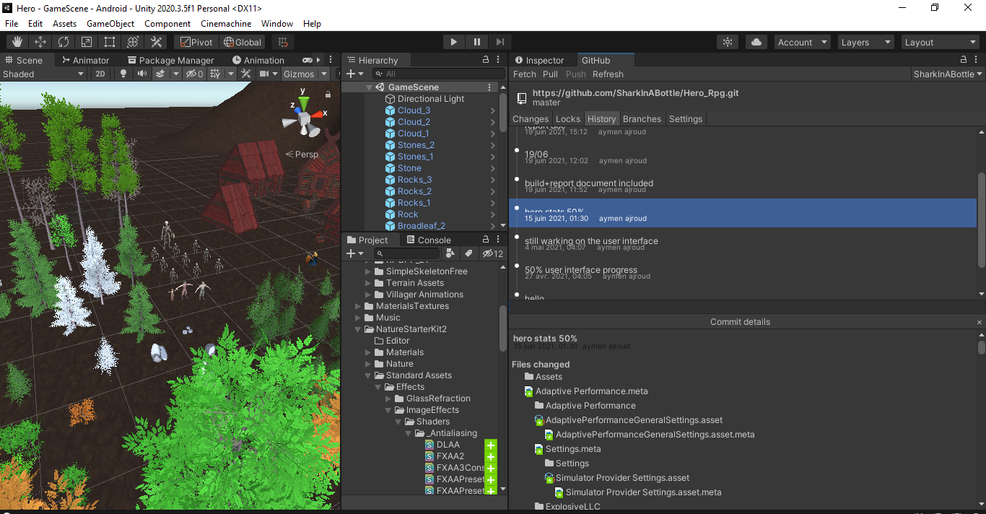

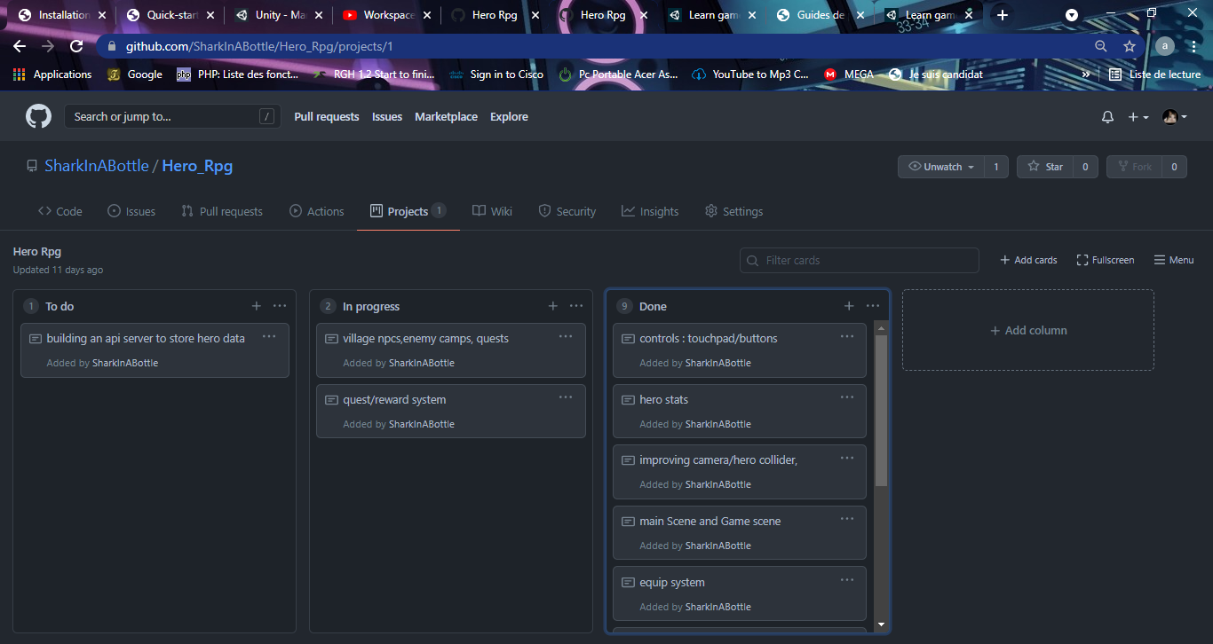

## Polish:

Particles, VFX and SFX help boost the game quality and improve the gameplay .

# Operations:

## Google/iOS developer account:

Google developer account requires 25$ for a lifetime subscription to google play store while apple require 99$ for 1 year.

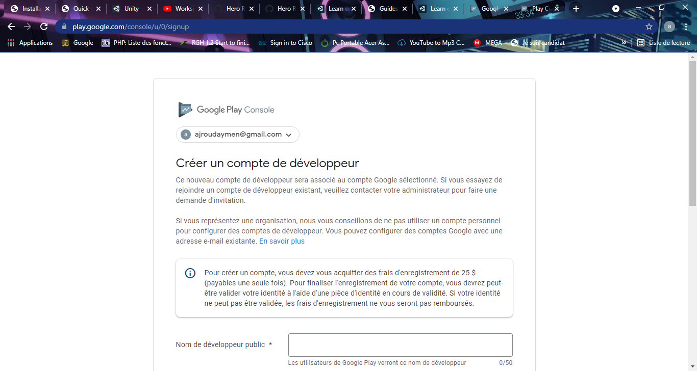

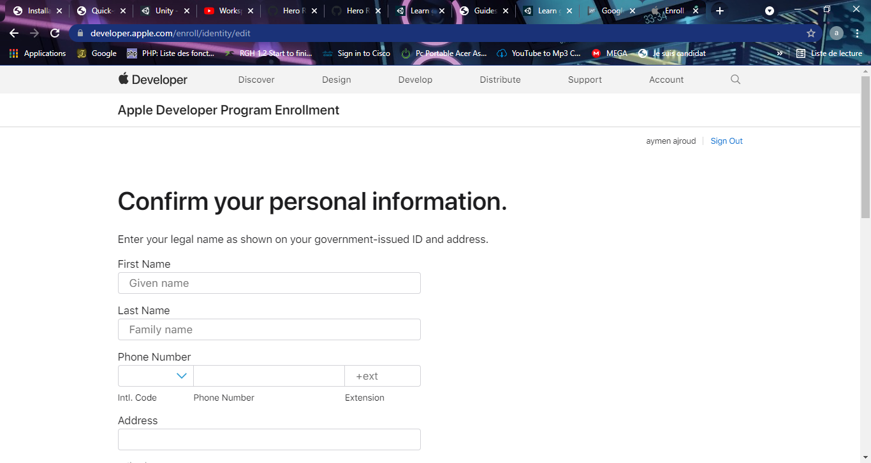

## Unity monetizing:

Monetization of your Unity project through ads is a great way to generate revenue without charging your customers directly. A successful free ad-supported game will bring in many times the asking price of an ad-free game that must be purchased outright. Though Unity Ads is one of the Unity Services, it is not in the default Unity package and must be downloaded from the Asset Store.

When you first enable Unity Services for a project, you are asked to assign the project to an organization. By default, your account has one organization: your username. Organization names must be unique. You can add (but not currently delete) more names, or rename an account at will, as long as the proposed new name is available. You might wish to have one organization for your solo projects, and one for your team.

Ads are shown in designated placement zones in your project. Rather than a literal scene or GameObject, a placement zone is just a mode defining how your players can interact with ads. Options include muting the audio and if or when they can skip the ad. For example, you would not want players to have the ability to skip a lucrative rewarded video. All projects in the Dashboard begin with two placement zones, video and rewarded Video, for regular and incentivized video ads.

## Reviews and updates:

The Google Play Developer Reply to Reviews API allows you to view user feedback for your app and reply to this feedback. You can use this API to interact with users directly within your existing customer support toolkit, such as a CRM system.

The Reply to Reviews API allows you to access feedback only for production versions of your app. If you want to see feedback on alpha or beta versions of your app, use the Google Play Console instead. Also, note that the API shows only the reviews that include comments. If a user rates your app but does not provide a comment, their feedback is not accessible from the API.

## Updates and continued maintenance:

Based on game reviews, further concept and design review and updates for the game are made and must go through the production cycle again.

# Conclusion:

Looking back, I am very happy that I chose this path. The project structure taught me a lot and my failures allowed me to improve as a developer.

No doubt I consider this game a success and I am more than proud about what I created, but as always, I believe I could have done better.

I now know how to shift attention during development and manage time in a more productive way.

I am looking forward to building more games and learning a lot more.